BPMN diagrams:
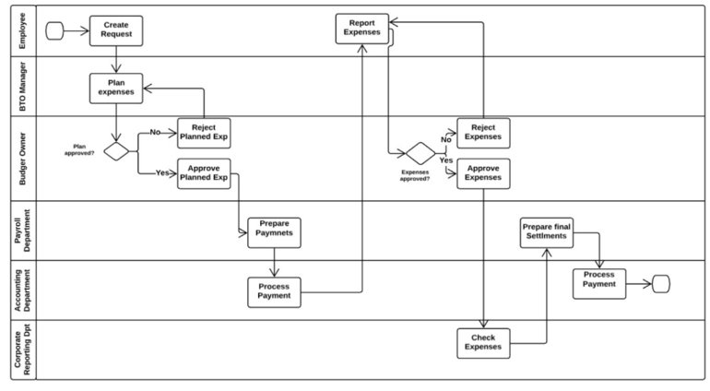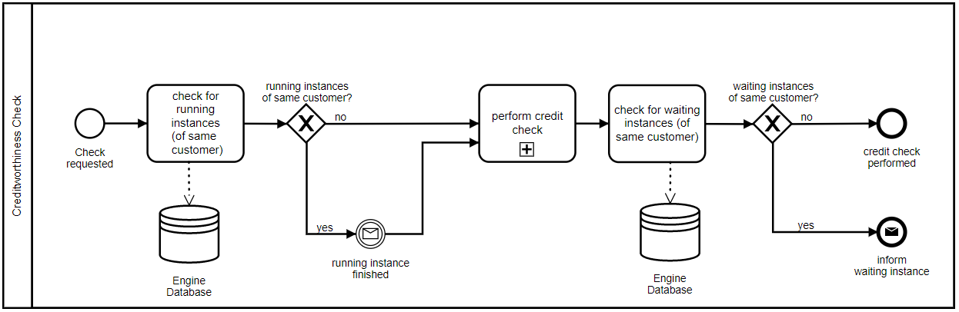
Tools:
https://www.lucidchart.com/
https://www.bizagi.com/
https://app.diagrams.net/
https://demo.bpmn.io/

BPMN poster:

